Voorbereiding: Packet Tracer - Basic Switch and End Device Configuration

# Addressing Table

|  |  |  |  |
| --- | --- | --- | --- |
| **Device** | **Interface** | **IP Address** | **Subnet Mask** |
|  | VLAN 1 |  | 255.255.255.0 |
|  | VLAN 1 |  | 255.255.255.0 |
|  | NIC |  | 255.255.255.0 |
|  | NIC |  | 255.255.255.0 |

# Objectives

* Configure hostnames and IP addresses on two Cisco Internetwork Operating System (IOS) switches using the command-line interface (CLI).
* Use Cisco IOS commands to specify or limit access to the device configurations.
* Use IOS commands to save the running configuration.
* Configure two host devices with IP addresses.
* Verify connectivity between the two PC end devices.

# Scenario

As a recently hired LAN technician, your network manager has asked you to demonstrate your ability to configure a small LAN. Your tasks include configuring initial settings on two switches using the Cisco IOS and configuring IP address parameters on host devices to provide end-to-end connectivity. You are to use two switches and two hosts/PCs on a cabled and powered network.

# Instructions

Configure the devices to fulfill the requirements below.

# Requirements

* Use a console connection to access each switch.
* Name and switches.
* Use the password for all lines.

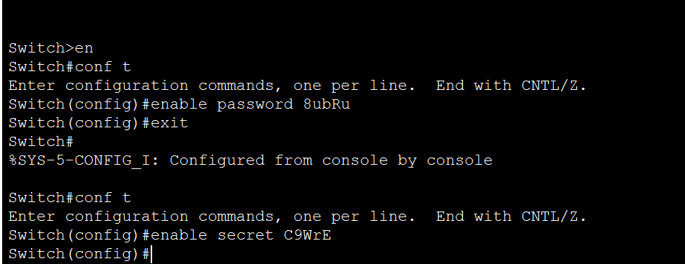

* Use the  secret password.
* Encrypt all clear text passwords.

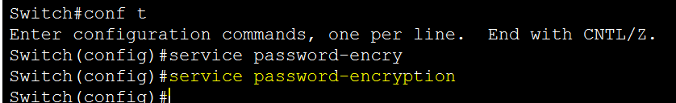

* Configure an appropriate message-of-the-day (MOTD) banner.

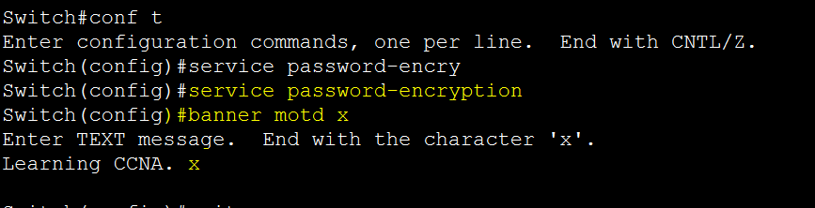

* Configure addressing for all devices according to the Addressing Table.

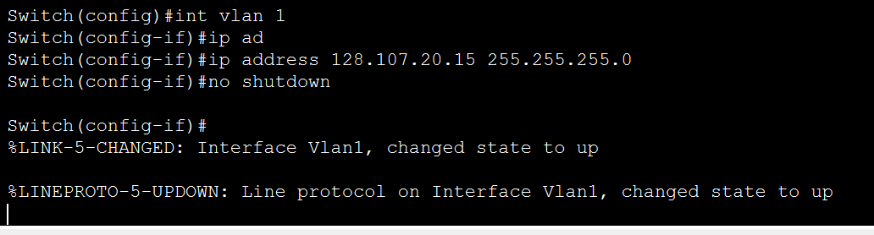

* Save your configurations

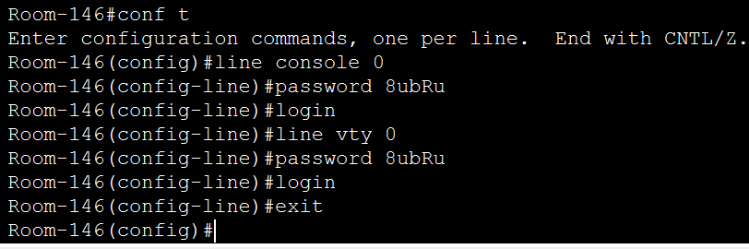

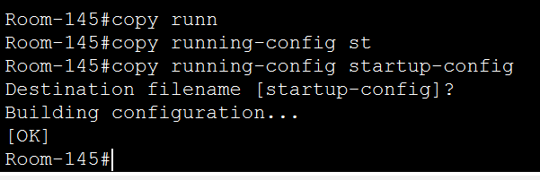

* Verify connectivity between all devices.

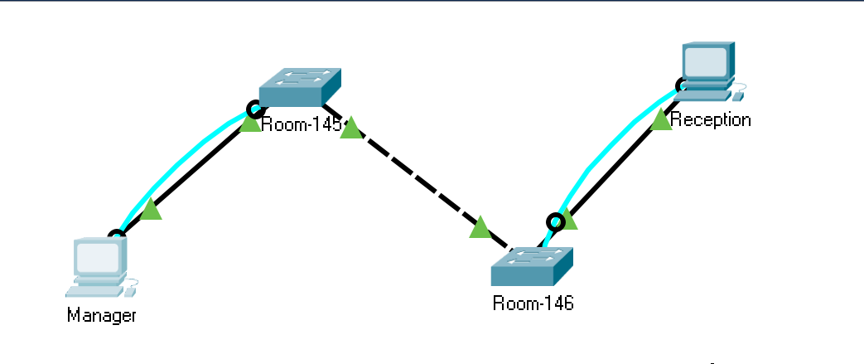

**Note:** Click **Check Results** to see your progress. Click **Reset Activity** to generate a new set of requirements. If you click on this before you complete the activity, all configurations will be lost.

*End of Document*